# EMBEDDED SYSTEM DESIGN

# LAB ASSIGNMENT -4

**STM8 UART data Transmission Asynchronously and display the logical state of the Pins.**

# SUBMITTED BY-

# SANCHIT AGRAWAL (2016H140106) ABHINAV GARG (2016H140103)

**Objective** – To send I/O Pin Status over Asynchronous serial (UART) link.

Enable serial communication between PC and microcontroller using UART link, For example declare any two GPIO pins as input and logical state (high / low) of those pins will be reported over UART to the external serial device using PL2303 USB to Serial converter module to communicate with the PC.

**Project Workspace: -**

* Used IAR embedded workbench with embedded C coding and used ST
* Visual Programmer for programming the STM8S micro controller

**Critical Issues: -**

* Baud rate should be matched between master & slave for proper data transmission.
* Monitor TXE bit to ensure the frame of data has been transmitted and TC bit for successful data transmission.

**Methodology** – HSI Master Frequency of 16 (MHZ) is selected and given to UART. Data transmission however is asynchronous. UART is connected to STM8S by giving a baud rate of 9600 through port D pins D5 and input is given through the pins B0 & B1 as per our input, the output will get printed in the putty continuously.

**FLOW CHART-**

Check PD.1,2 status

Display ‘low’ on putty through UART

Status low

Status high

Display ‘high’ on putty through UART

Send Data for Transmission into UART data register

Bit is empty

Bit non empty

MonitorTXE bit

Configure UART registers to set baud rate 9600, frame for 8 data and 1stop bit and other control registers.

Set Monitoring pins PD.1,2 as Output

**\**

**HARDWARE DESIGN**

Used an UART and connected it to port D (pin 5). The Rx of PL 2303 connected to TX of Microcontroller. The Result of the Pins i.e. whether High or low is observed on putty.

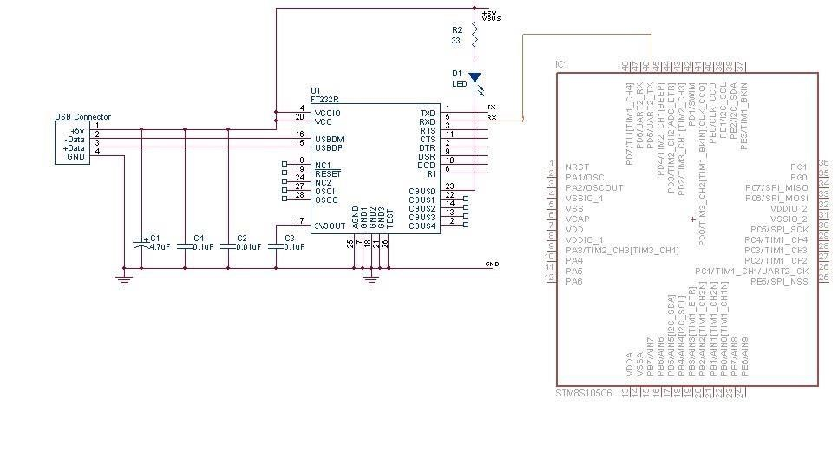

(Schematic Diagram of the Processor STM8S105C6 along with the Connections)

Used an UART and connected it to port D (pin 5). The Rx of PL 2303 connected to TX of Microcontroller. The Result of the Pins i.e. whether High or low is observed on putty.

# Software Design –

Used Basic UART initializing instructions to enable the data transmission. Used TXE and TC bits to check the data flow.

# Explanation –

* Header <STM8S.h> is containing all the register definitions which enables us to use register names instead of Memory location of every SFR.
* Since UART2 is available at PORT D (5), we must configure port D as output. D5 bits of GPIOD ->DDR is made 1.
* A delay function using FOR loop is used to provide the delay during UART communication process for accurate results.
* The pin configuration of PORT B is being checked so they are configured as INPUT. GPIOB->DDR=0
* The HSI clock is used and is not prescaled so that peripheral clock frequency is 16 MHz
* The UART2 is configured at the baud rate of 9600 bps using BRR registers.
* The string data transmission is done only after checking TXE and TC signals in CR2 and SR registers respectively.

The c code for the above is sent as an attachment for reference.

**Observation & Result** – The Logical state of the I/O pins displayed by using the data transmission through UART asynchronously.

**References: -**

* RM0016 – STM8S105C6 user manual
* STM8S Datasheet for connections.